Create Scripted DevOps Pipeline using Jenkins => Get IP address

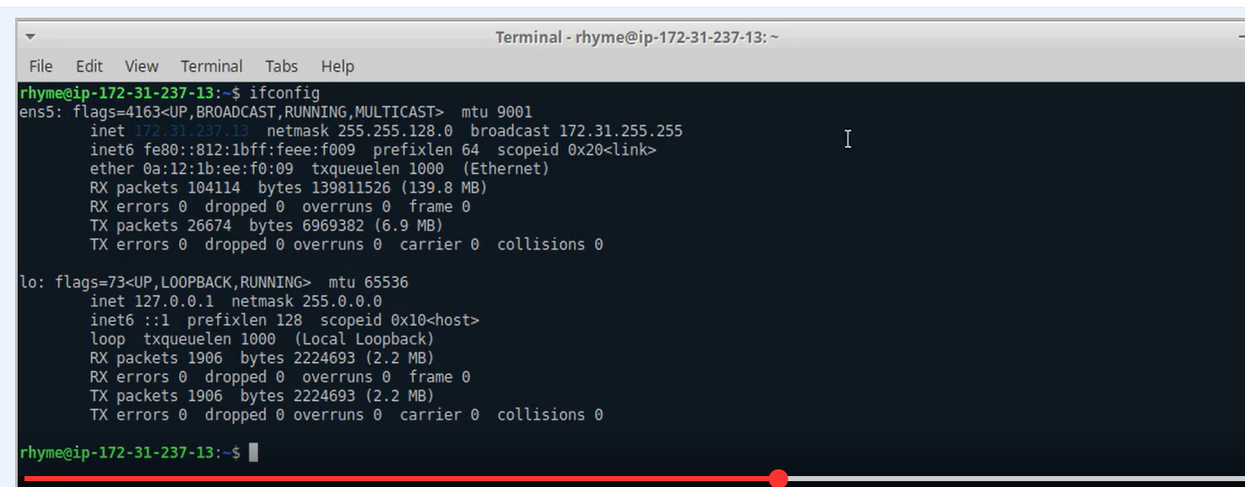

Java APP using Maven tool => Global tool configuration

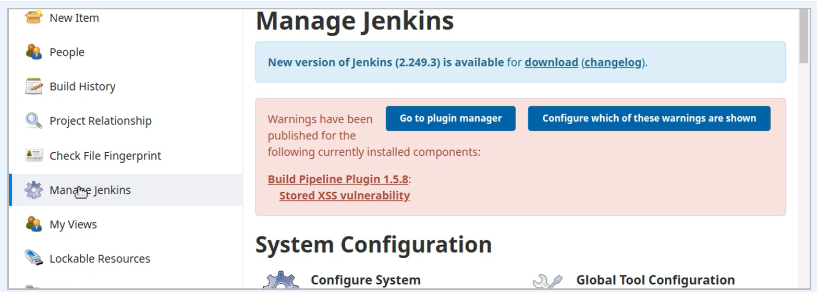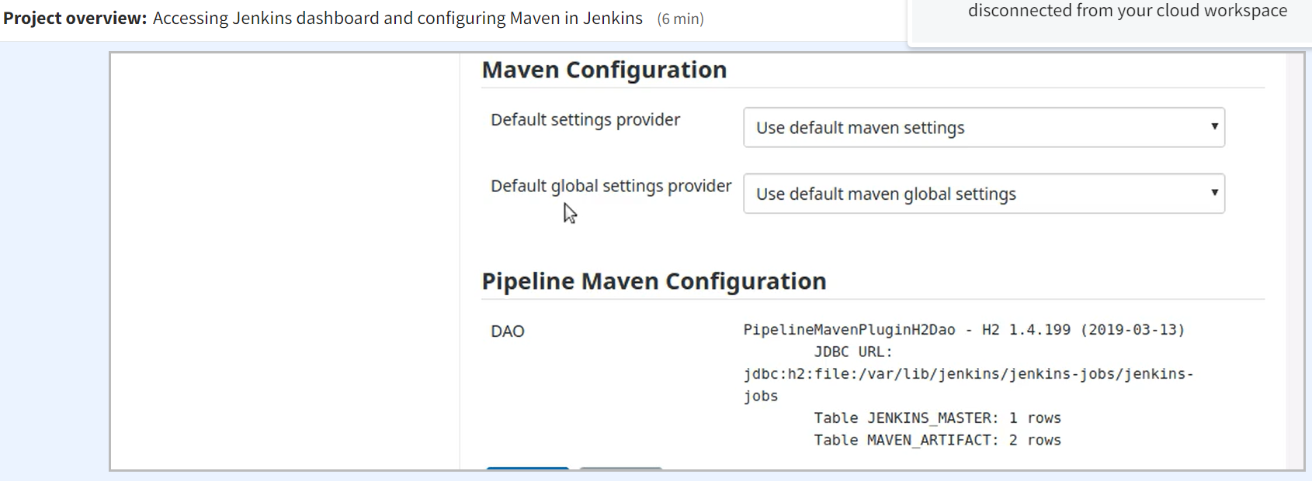

Go to Maven installations => Add Maven => Add Maven name

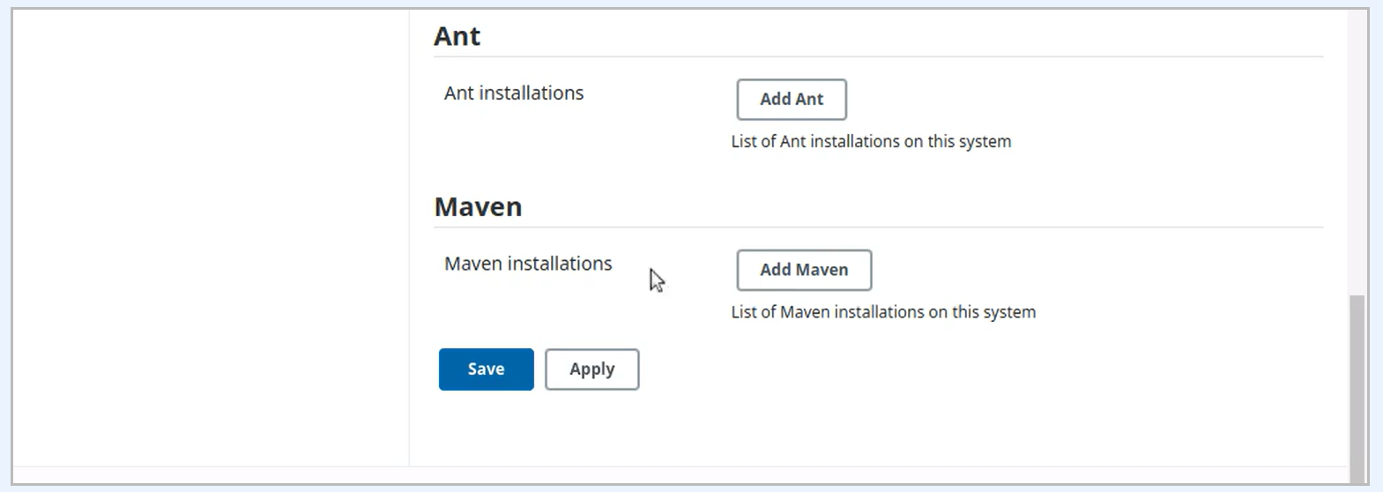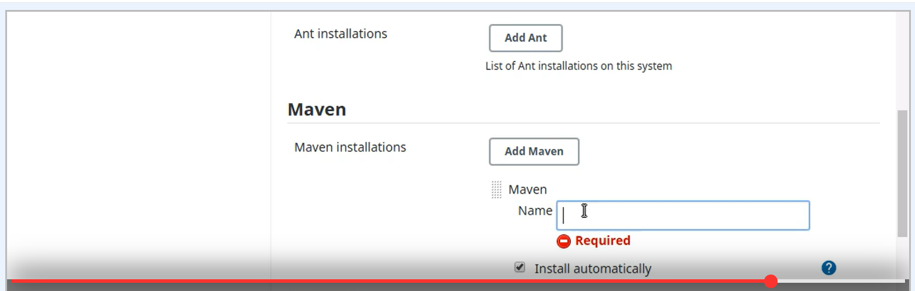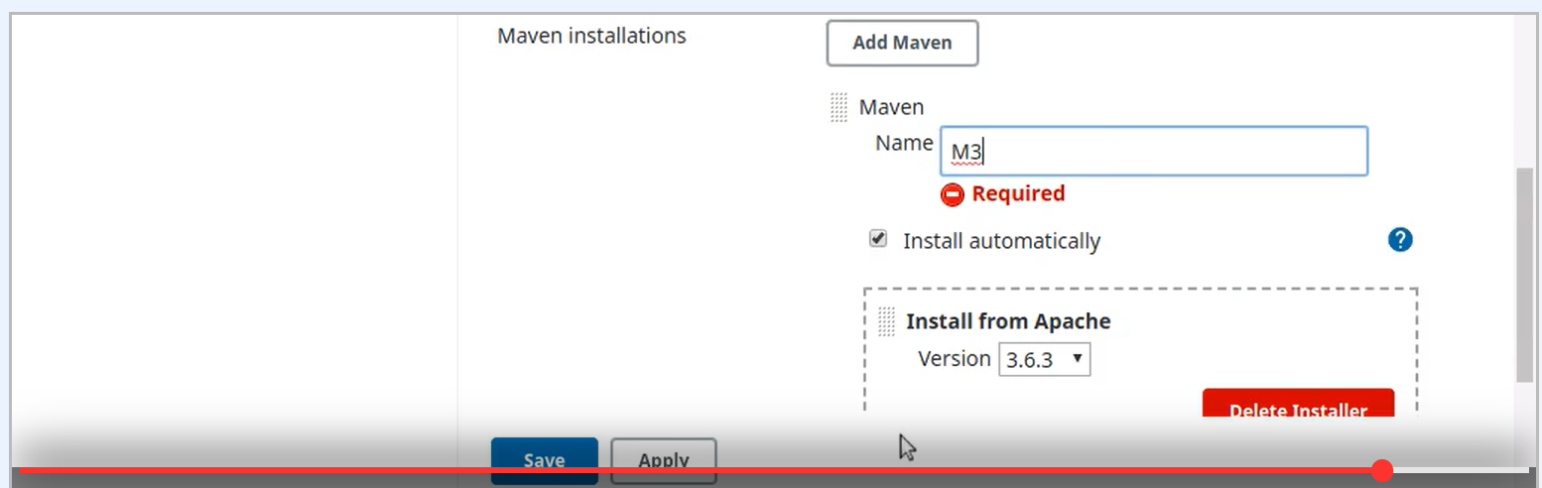

Go to GitHub Fork the Repo of my source code

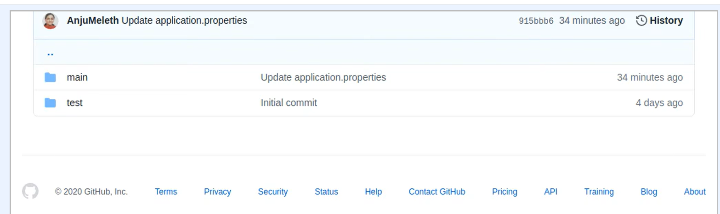

Go to Manage Plugin => Add Pipeline plugin

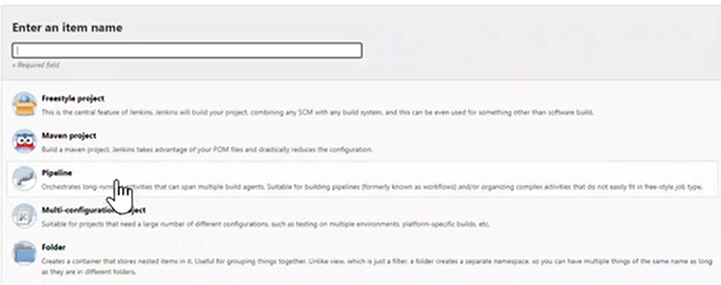

Create Jenkins Pipeline => Put the Description of your pipeline

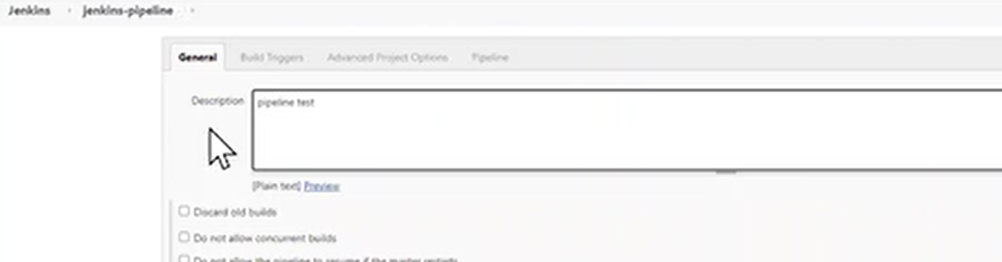

Start your scripted Pipeline + Save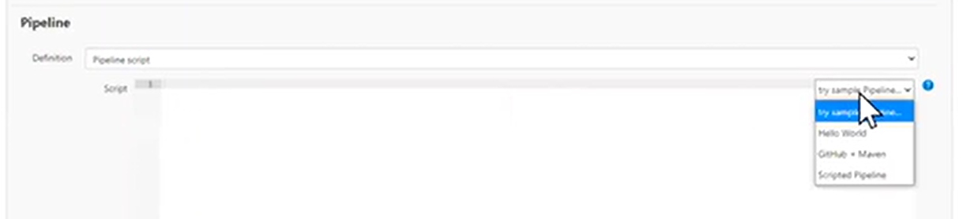

Put all the pipeline Stages

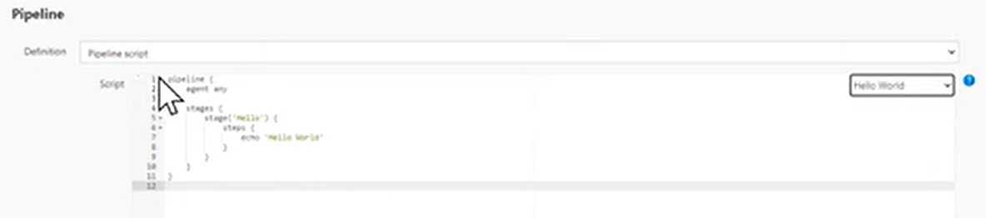 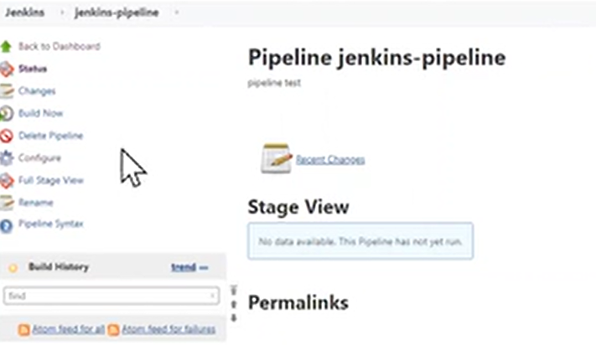

Click on Build now

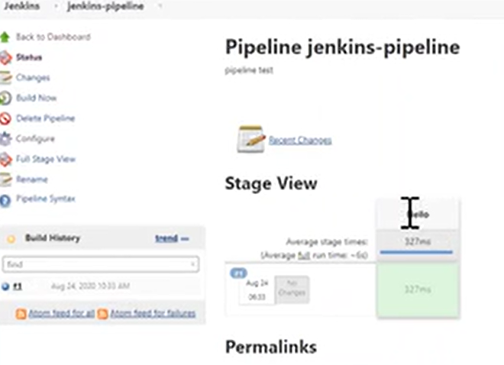

Check your build in Console Output

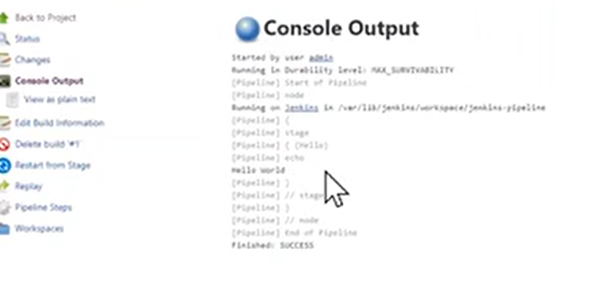

Modify your Pipeline Stage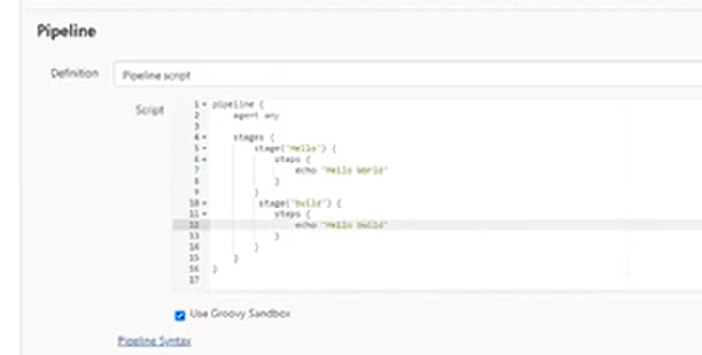

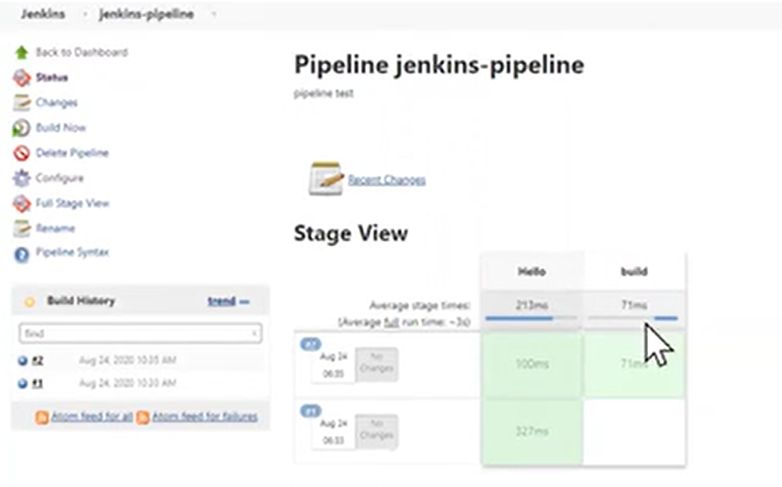

Create Declarative DevOps Pipeline Project => from Pipeline Script for SCM

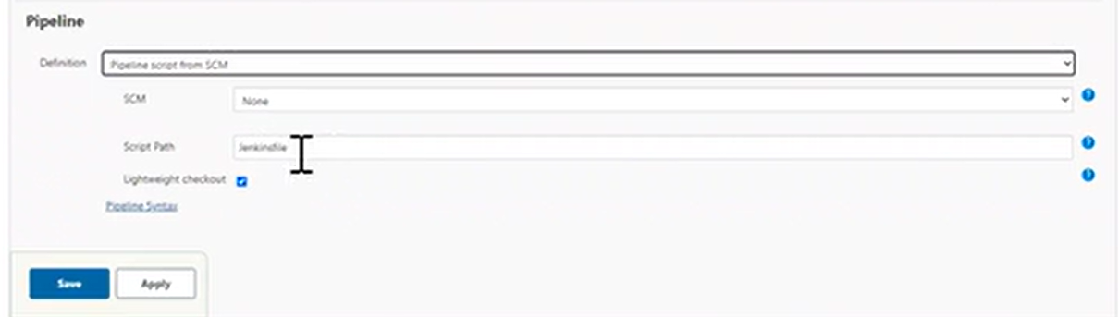

Select Git for your source code => find your Jenkinsfile and past => Branch = Master => Save + Build

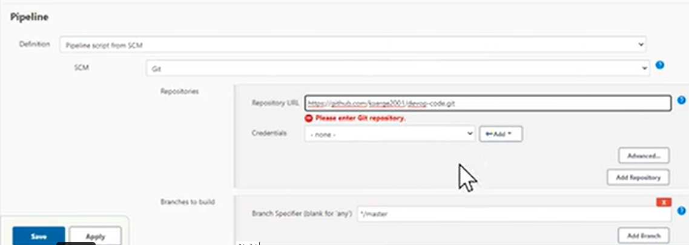

Build your Declarative Pipeline in Git + Build

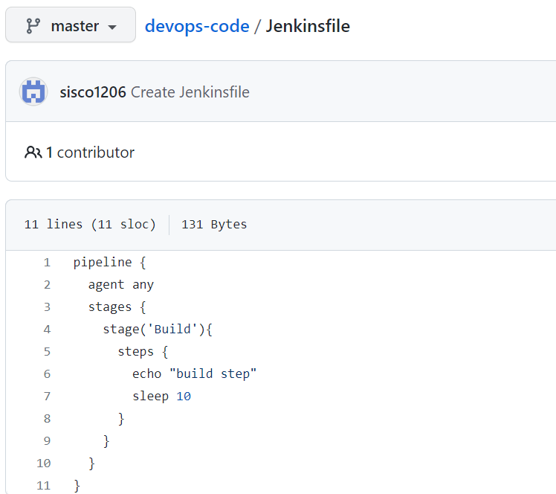 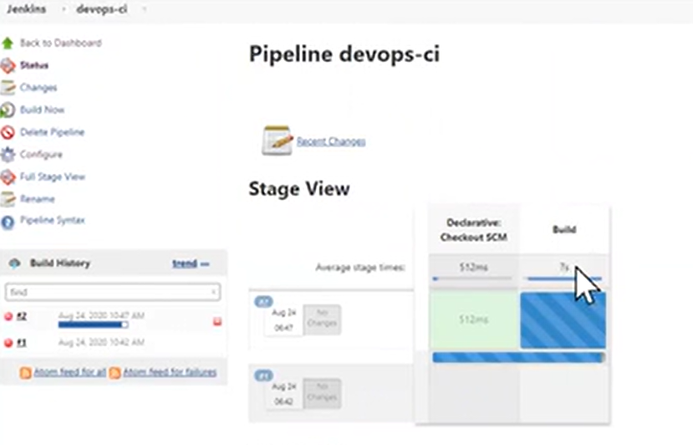

Build Declarative Pipeline with 4 stages

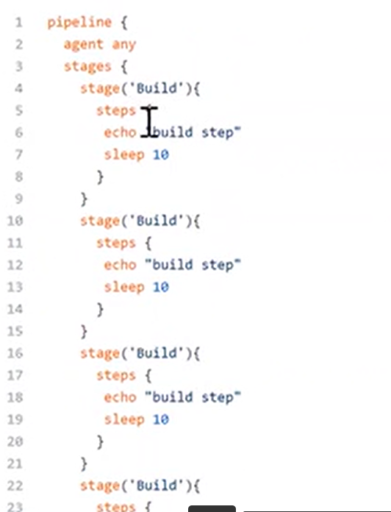 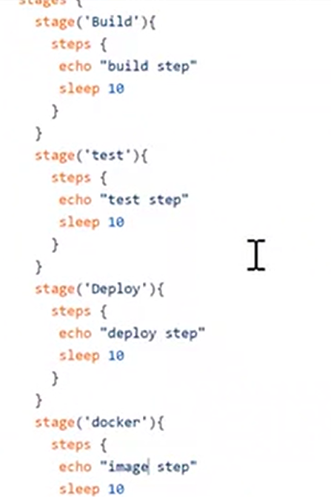 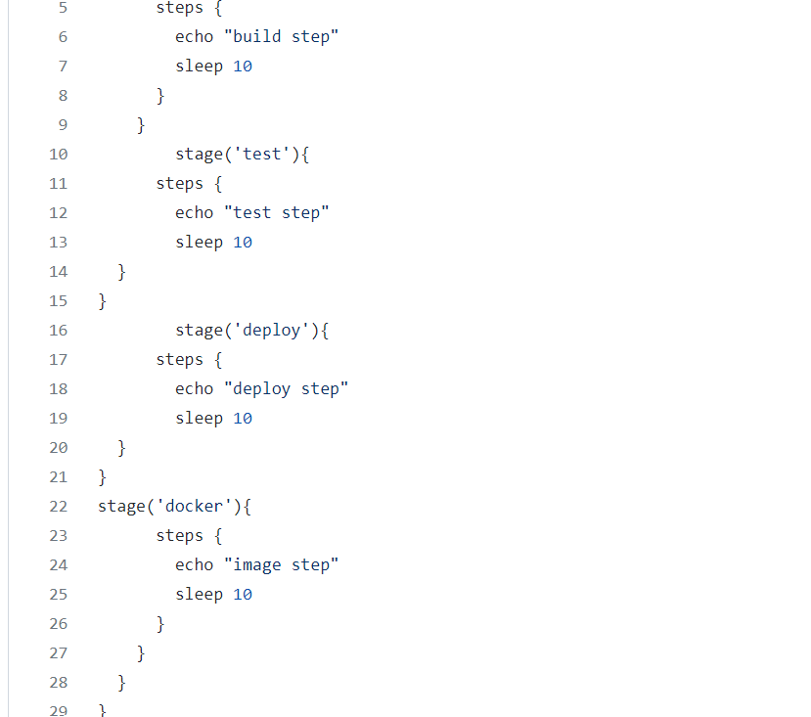

Build a Maven Job => to Create a War file

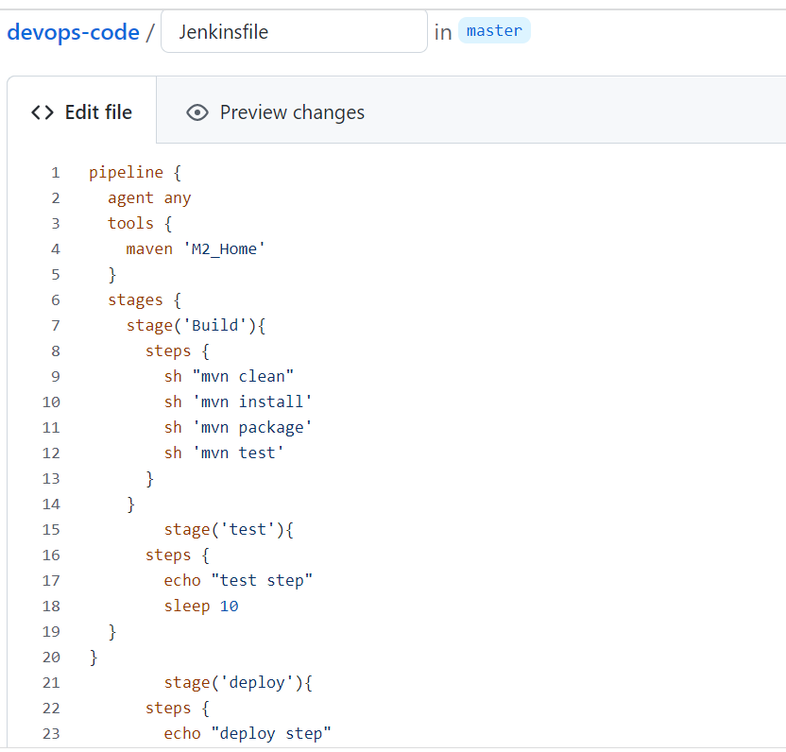

Set up Jenkins to deploy Docker image

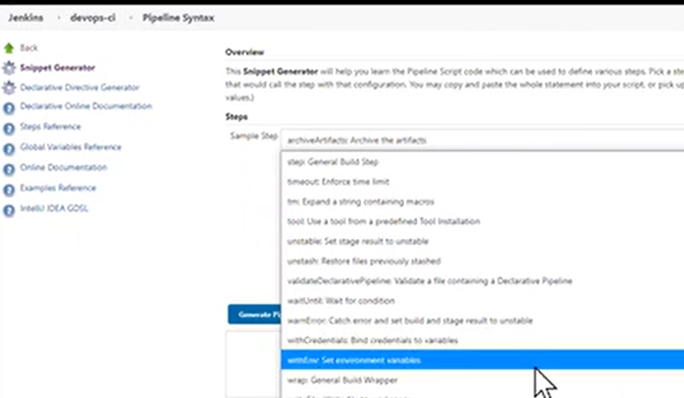

Modify new staging => Create env variable

